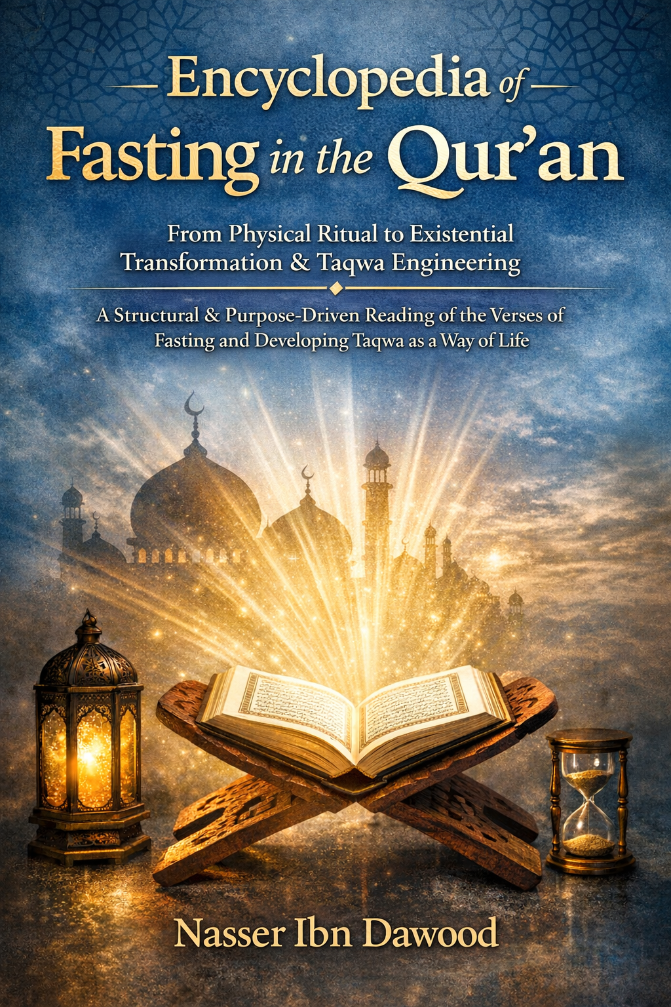
This is a condensed conceptual adaptation of your work, "The Fasting Series"), designed for the global academic and research community.

I. The Global Knowledge Manifesto Knowledge is a universal right. The author firmly believes that wisdom should not be locked behind paywalls or language barriers.
Global Access Policy: All books in this library are available for free in multiple digital formats (PDF, HTML, DOCX, TXT).
The Digital Library: As of early 2026, the collection hosts 68 volumes (34 in Arabic and 34 in English), fully optimized for AI-assisted research and digital archiving.
Official Platforms: * Main Website: nasserhabitat.github.io/nasser-books/
- GitHub: nasserhabitat/nasser-books
II. Translator’s Note: The Bridge of Meaning This English edition is a condensed conceptual adaptation. It is not a word-for-word translation, but rather an "extraction of essence." It presents the core philosophical framework in accessible English, omitting the exhaustive linguistic debates and classical references found in the original Arabic text.
For the academic researcher: The original Arabic version remains the primary source for comprehensive linguistic analysis, detailed exegesis (Tafsir), and the complete bibliography.

From Physical Ritual to Existential Method and the Architecture of Taqwa
Encyclopedia of Qur’anic Fasting
From Ritual Practice to Existential Method: A Structural and Maqasid-Based Reading of the Fasting Verses and the Construction of Taqwa as a Way of Life

Encyclopedia of Qur’anic Fasting
From Ritual to Existential Transformation

A Conceptual Translation
Chapter 1: The Paradigm Shift: Ritual vs. Methodology
The common understanding of fasting (Siyam) is often reduced to the physical act of abstaining from food, drink, and intimate relations from dawn to sunset. While jurisprudentially correct, this reductionist view transforms a profound act of worship into a repetitive, spiritless ritual. This book proposes a shift in perspective: viewing Siyam not as mere physical deprivation, but as a comprehensive intellectual and spiritual methodology (Manhaj) designed to elevate human consciousness.

The ultimate goal of Siyam is the attainment of Taqwa (Conscious Awareness/God-consciousness). This state is not achieved through physical hunger alone, but through a deliberate process of "Tadabbur" (deep Quranic reflection) and "Tazkiyah" (self-purification).

Chapter 2: The Semantics of Restraint: Sawm vs. Siyam
A critical linguistic distinction is made between the Quranic terms Sawm and Siyam:

- Sawm (Specific Abstinence): Refers to a temporary, situational restraint from a specific act, such as Mary’s vow of silence (Sawm from speech).

- Siyam (Comprehensive Methodology): Represents a continuous state of awareness. It encompasses both physical abstinence and, crucially, an "intellectual fast"—the restraint from speaking about religious matters or the Quran without deep, systematic reflection.

Chapter 3: Re-coding the Quranic Lexicon
The methodology of this work involves a "re-reading" of key terms within the Quranic verses of fasting (Al-Baqarah: 183-187):

- Ayyam Ma'dudat (Numbered Days): Rather than just the calendar days of Ramadan, these represent dedicated periods for the "census" and auditing of Quranic verses—intensive study sessions aimed at extracting deeper meanings.

- Sickness & Travel: "Sickness" is conceptually interpreted as intellectual doubt or mental uncertainty that hinders true understanding. "Travel" represents the ongoing journey of seeking truth; those still "on the road" to understanding are granted the time to complete their intellectual pursuit until they reach certainty.

- The Internal Valve: Siyam acts as an internal cognitive filter. Just as one guards what enters the stomach, the "Internal Valve" guards what enters the mind, filtering out "Stray Mountains"—those inherited, rigid, and unverified ideologies that block the light of the Quranic text.
Chapter 4: Intellectual Solidarity (Scientific Takaful)
The concept of "feeding the poor" (Fidya) is expanded into the realm of knowledge.

- The Intellectual Poor (Maskeen): Refers to those who have "stagnated" in their reflection or lack the tools for deep understanding.
- Scientific Solidarity: Those with "abundance" (knowledge and expertise) are tasked with "feeding" the intellectually poor by teaching them the tools of Tadabbur and sharing cognitive insights. This creates a community where knowledge is shared as a form of social and spiritual mercy.

Chapter 5: Proclaiming the Truth: Ramadan and the Quran
- Shahru Ramadan: Derived from Shuhra (proclamation) and Ramdha (scorching heat/resistance). It signifies the public proclamation of the Quranic truth despite the "scorching" resistance of those who hold onto false ideologies.

- Al-Quran: Rooted in the concept of Qaran (pairing/coupling), meaning the methodology of comparing the literal text with its internal essence to arrive at a unified truth.
Conclusion: The Journey to Al-Furqan
By embracing Siyam as an intellectual methodology, the believer moves from "Physical Ritualism" to "Cognitive Satiation". This journey transforms the month of Ramadan into a global workshop for reflection, where the ultimate reward is the Furqan—the ability to distinguish between truth and falsehood through the light of the Quran.

I. The Global Knowledge Manifesto
Knowledge is a universal right. The author firmly believes that wisdom should not be locked behind paywalls or language barriers.
- Global Access Policy: All books in this library are available for free in multiple digital formats (PDF, HTML, DOCX, TXT).
- The Digital Library: As of early 2026, the collection hosts 68 volumes (34 in Arabic and 34 in English), fully optimized for AI-assisted research and digital archiving.
- Official Platforms:
  - Main Website: nasserhabitat.github.io/nasser-books/
  - GitHub: nasserhabitat/nasser-books
II. Translator’s Note: The Bridge of Meaning
This English edition is a condensed conceptual adaptation. It is not a word-for-word translation, but rather an "extraction of essence." It presents the core philosophical framework in accessible English, omitting the exhaustive linguistic debates and classical references found in the original Arabic text.
For the academic researcher: The original Arabic version remains the primary source for comprehensive linguistic analysis, detailed exegesis (Tafsir), and the complete bibliography.

The Siyam Series: From "Physical Ritual" to "Comprehensive Cognitive Methodology"
1. المرتكز المنهجي: الصيام كعملية تحرير للعقل
1. The Methodological Anchor: Fasting as a Process of Cognitive Liberation
In English: The ultimate goal of fasting in this work is not physical deprivation, but the liberation of the mind from inherited "programming." Fasting is a "System Reset" for the internal self, where abstinence evolves from a negative act (quitting food) to a positive act (installing an internal valve) to filter information and ideas.

2. The Duality of Sawm and Siyam: A Linguistic Distinction
In English: The book distinguishes between Sawm as a situational abstinence from a specific act (like Mary’s vow of silence) and Siyam as a sustainable life methodology. Siyam is the mind's silence from speaking about the Divine Word without knowledge and the restraint from following "Stray Mountains" (rigid, unverified traditions).

3. Installing the "Internal Valve" and Deconstructing "Stray Mountains"
In English: The author introduces the concept of "Stray Mountains"—false cognitive accumulations and mental idols that block the vision of truth. True fasting requires activating the "Internal Valve," which prevents the spirit and heart from being fed with intellectual toxins (envy, malice, tribalism), allowing for "Cognitive Satiation" from the Quranic source.

4. Collective Tadabbur: Toward a "Cumulative Collective Mind"
In English: The book shifts from "Individual Reflection" to "Open Collective Tadabbur." Ramadan is viewed as a "Universal Laboratory" where believers gather to study verses (cumulatively) without monopolizing the truth. Authority belongs to the text alone, and minds intersect to reveal the Furqan—the ability to distinguish between truth and falsehood in our contemporary reality.

5. Re-interpreting "The Balance" and "Cognitive Adultery"
In English: The book expands the concept of Al-Mizan (The Balance) to include professional excellence and justice in relationships. It also presents a bold interpretation of "Adultery" (Zina) in its broader sense: the disruption of the balance in any relationship (fraud, falsification, exploitation), asserting that Siyam is the guardian that prevents this imbalance.

6. Conclusion: Elevating to the Level of "Glorifying Allah"
In English: The end of the fasting journey in this book is not merely the joy of Eid at the end of deprivation, but the "Magnification of Allah" (Takbir). This means Allah becomes greater in our consciousness than all internal idols and fears. It is the transition from "Ritual" to "Methodology" and from "Hunger" to "Sovereignty."

